2023 Carnell Russ Day
Community Unity Festival

Saturday, September 30 & Sunday, October 1, 2023
Community Unity Festival
Saturday
10:00 AM – 5:30 PM
Southwest Christian Academy
11301 Geyer Springs Rd, Little Rock, Arkansas
FREE! FREE! FREE! FREE! FREE! FREE! FREE! FREE! FREE! FREE! FREE! FREE! FREE! FREE! FREE! FREE!
Health Fest
Historical Exhibits
Speakers
Vendors
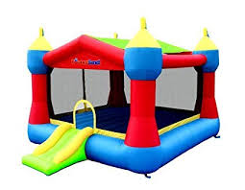
Youth & Children Activities
Entertainment
Sunday
Gospel Academy Concert 4p-6p
SW Christian 11301 Geyer Springs
& MORE!
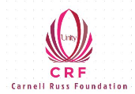A FREE Festival for ALL!
www.carnellrussfoundation.com

For Sponsor, Vendor, Volunteer, Festival Info: unityfest3@yahoo.com / 501.541.3732 text
Find and on Facebook / Follow on Instagram

